Functional Document

FT DAL Excel Data Wizard

November 8, 2023

Indium software

Contents

Document History 2

Functional Overview 2

Technology Used 2

Mosaiq Approach 3

JSON Input (Landing Home Screen) 4

List of Fields 4

Field Input 5

Paramerets 6

Sub Fields 6

Filters 7

Other Key Values 8

Nested Field 8

Nested Subfield 9

Nested Filters 10

Nested Others 10

Save Parameters 11

Entity Search 12

Date Selection 13

o Range 13

o Snapshot 13

o Series 13

Report Screen 14

Excel Plugin Approach 15

Ribbon: 15

Settings Screen: 16

Fetch Data Screen: 17

Loading Data Wizard Screen: 17

Loading Data Wizard Screen: 18

Data Wizard Screen with Mosaiq: 18

Report from excel Plugin: 20

# Document History

|  |  |  |  |  |  |
| --- | --- | --- | --- | --- | --- |
| Version | Description | Updated by | Updated On | Action | Comments |
| Draft | FT DAL Excel Data Wizard | Apurva | 27-Oct-23 |  |  |
|  |  |  |  |  |  |
|  |  |  |  |  |  |
|  |  |  |  |  |  |
|  |  |  |  |  |  |
|  |  |  |  |  |  |

# Functional Overview

# DAL Excel Data wizard offers access to DAL APIs through comfort of Mosaiq Environment l. To use DAL efficiently, being able to write a proper request is of utmost importance. Wizard is used to create a request in steps and helps users in creating requests. A readymade request can be run directly as well. The output of the requests gets written to a sheet in the active Excel file.

# Technology Used

DAL-Excel Data Wizard is created using React JS, HTML, CSS, Visual Studio 2022, C# and Dot net Framework 4.08.

# Mosaiq Approach

FT Mosaiq login Dev URL [Unified Investment Portal (frk.com)](https://uipdev.frk.com/)

* Login Screen with SSO.
* Without login can’t be able to access Mosaiq UIP Platform.

DAL Excel Data Wizard screens 1

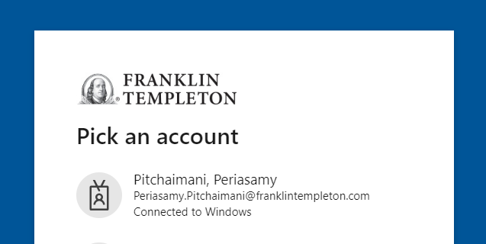

* After successful login with Mosaiq platform user will find the tails in Mosaiq UIP portal.
* User can select the “Data Wizard” tails the link will go to JSON input screen.

DAL Excel Data Wizard screens 2

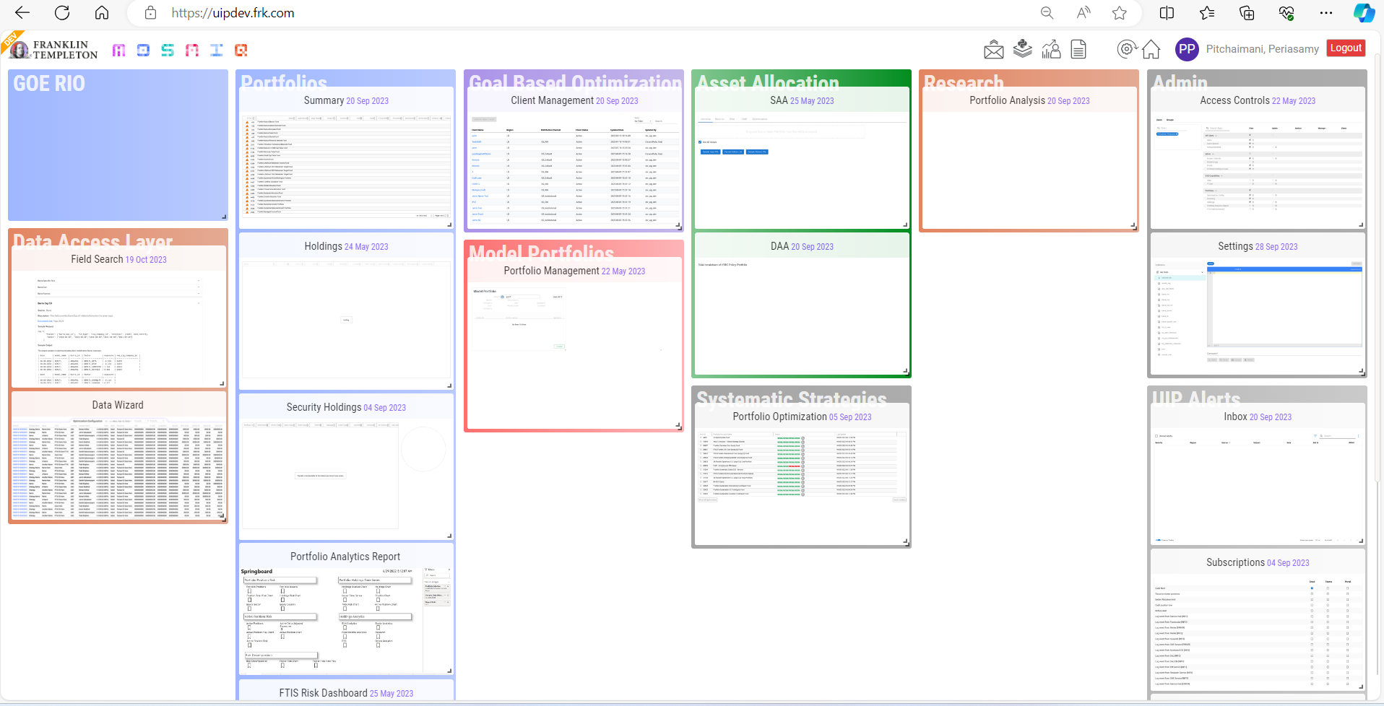

## JSON Input (Landing Home Screen)

* Enter JSON request string in the text box.
* “Fetch Data” button will send the JSON to API and populate results from the API in the New Excel sheet with help of DAL API response.
* Use “Clear Input” button to clear existing JSON Input.
* Use “Wizard” button to generate JSON request by entering input for Fields, Entities and Dates.
* Use “Cancel Button” to close the JSON Input Screen.

DAL Excel Data Wizard screens 3

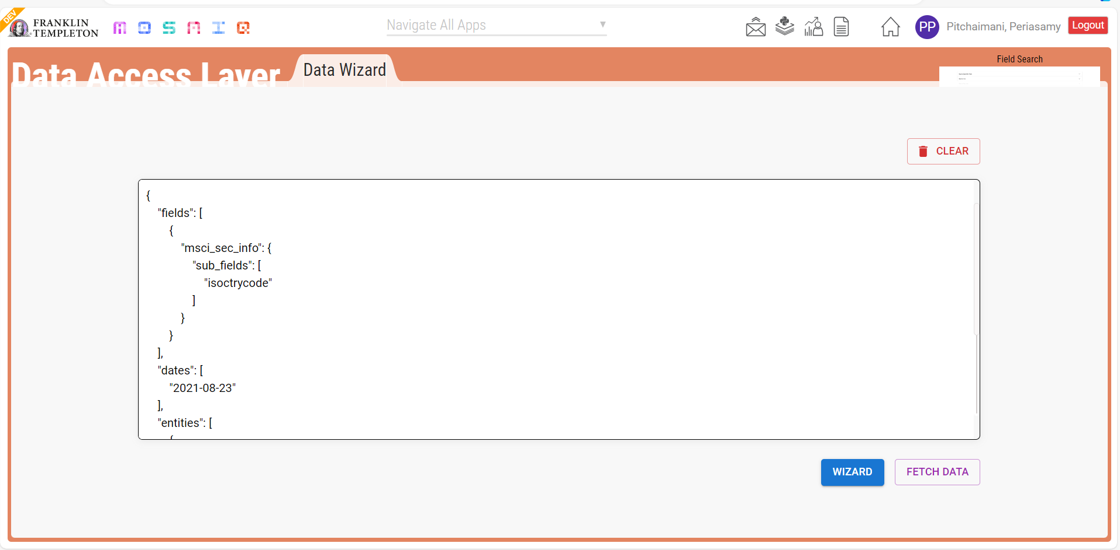

## List of Fields

* User can type the field on the search text the field name in the table.
* On double click the selected field will be added in filed grid in previous (Field Input Screen).
* Use “Cancel” button to close the List of field Input Screen.

DAL Excel Data Wizard screens 4

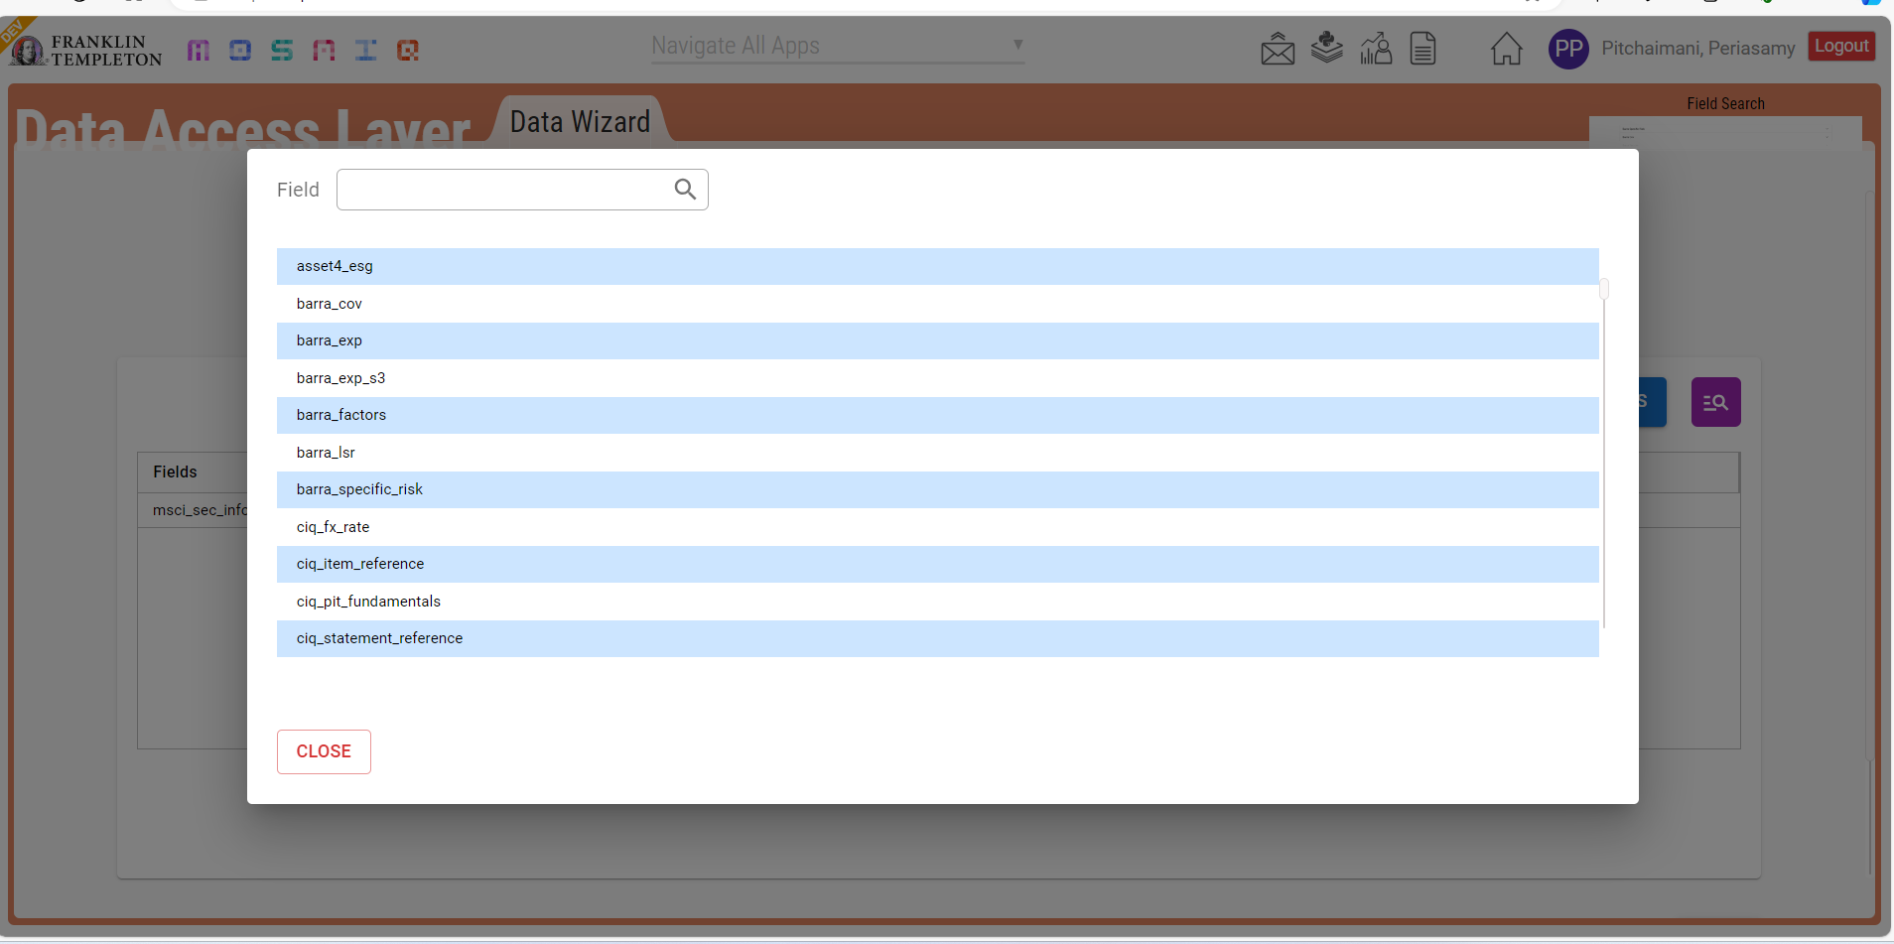

## Field Input

* Enter the Field name in Search text box to auto populate Field names as list based.
* The button with “List icon” will populate all available fields in the new window.
* User must click the “Add Field” button after selecting or entering the field name to add the field in the table View.
* Use “Edit” button from the Field table to input the parameters for each field in the table.
* Use “Delete icon” next to the parameter in grid to remove the field form the table.
* Next button will take to the Entity Screen.
* Use “Cancel” button to close the “Field Input” screen.

DAL Excel Data Wizard screens 5

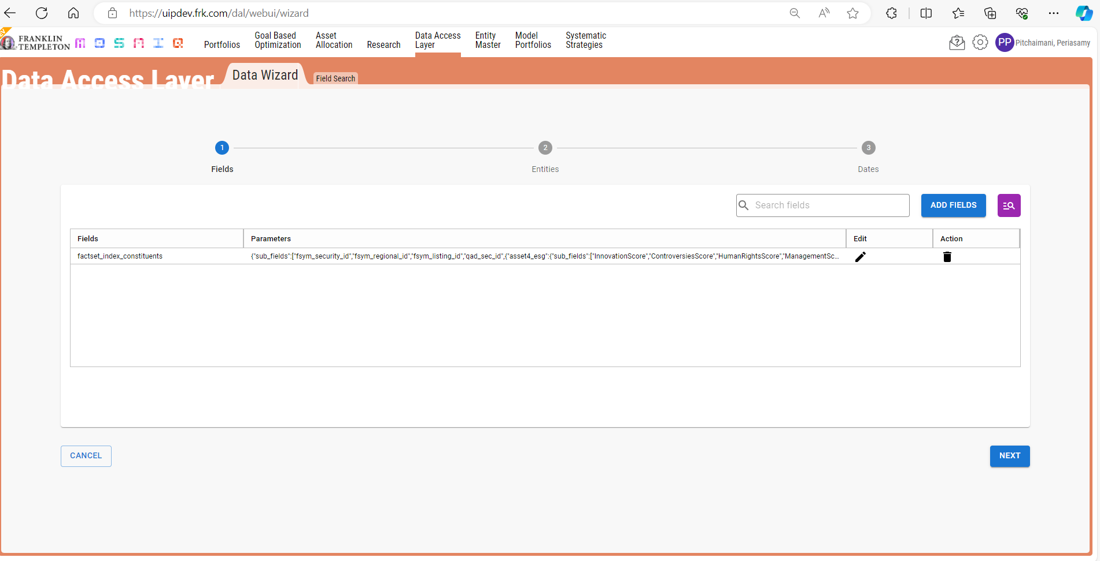

## Paramerets

The parameters screen has three sections Subfield, Filters and Other Key Values.

### Sub Fields

* Sub field is used to input the Subfield as text and user can search the subfield from fields as well as Entity master API after click the Add subfield button the subfield will be added in the table.
* Table is collection of all the subfields.
* Use “Delete icon” to remove sub field from the table.

DAL Excel Data Wizard screens 5.1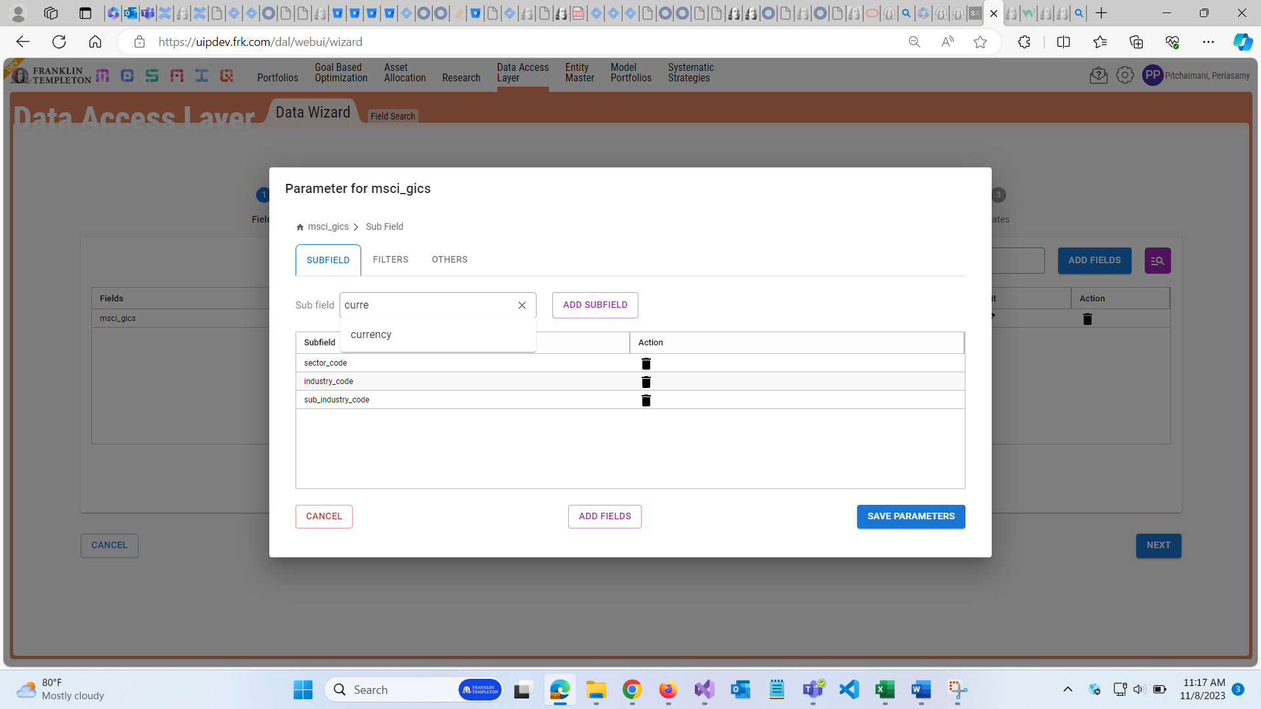

### Filters

* Filter is to input the idtype.
* Id(s) can be the text with multiple rows in the table.
* Use Delete icon to remove the Id from the table.
* DAL Excel Data Wizard screens 5.2

### Other Key Values

* Key,value is the input type, user can enter in key, value text boxs and click the add key value button to use to add in the grid. User can add multiple key and value in th table.
* Use “Delete icon” remove the key and value in the table.
* DAL Excel Data Wizard screens 5.3

### Nested Field

The nested field is combined with fields like added the and subfield, Filters and others.

* Enter the Field name in Search text box to auto populate Field names as list based.
* The button with “List icon” will populate all available fields in the new window.
* User must click the “Add Field” button after selecting or entering the field name to add the field in the table View.
* Use “Parameter” button in grid to input the parameters for each field in the table.
* Use “Delete icon” next to the parameter in grid to remove the field from the table.
* Next button will take to the Entity Screen.
* Use “Cancel” button to close the “Field Input” screen.

DAL Excel Data Wizard screens 6

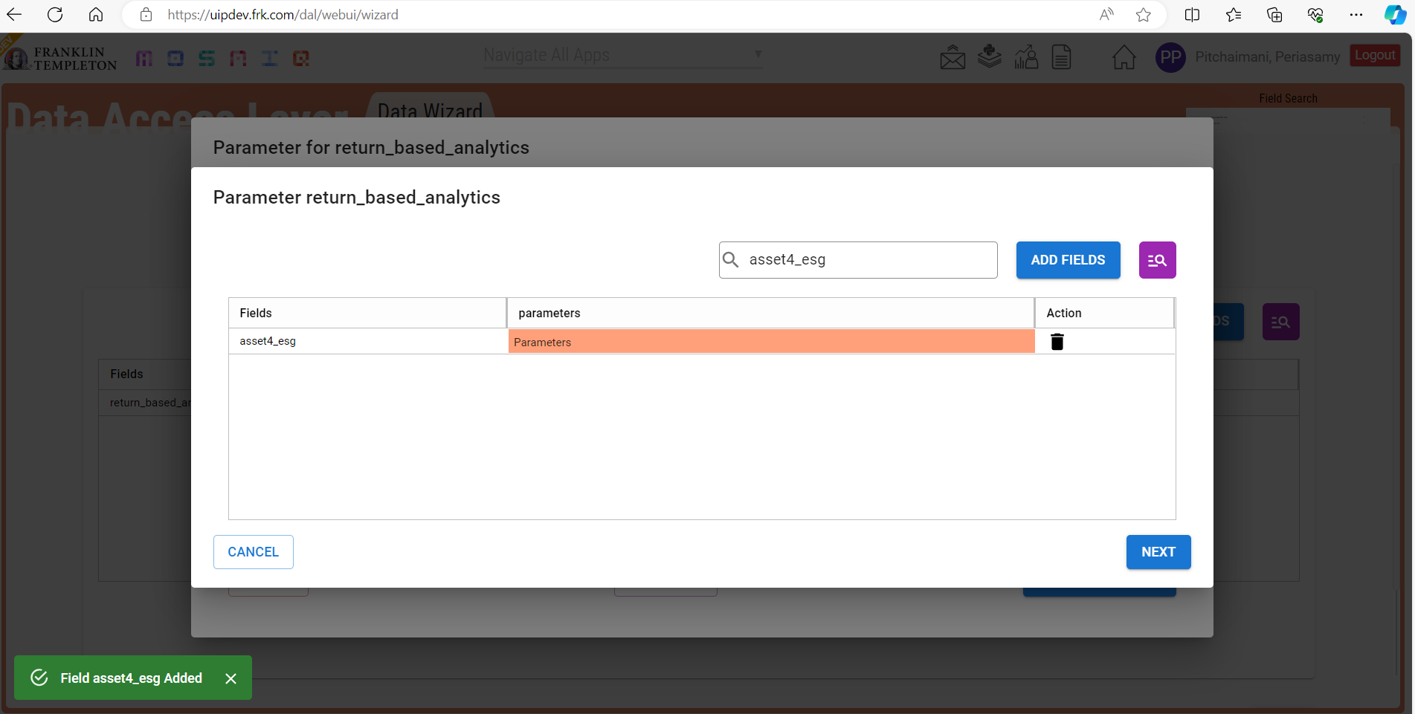

### Nested Subfield

* sub field is used to input the Subfield as text.
* Grid is collection of all the subfields.
* Use “Delete icon” to remove sub field from the table.

DAL Excel Data Wizard screens 6.1

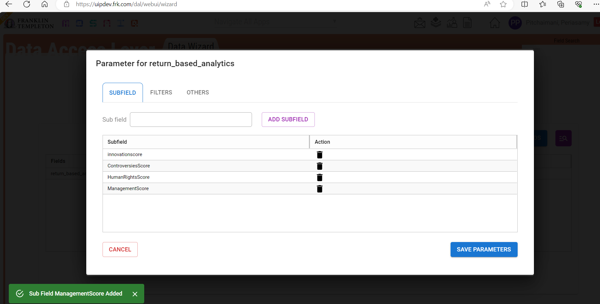

### Nested Filters

* Filter is to input the idtype.
* Id(s) can be the text with multiple rows in the table.
* Use Delete icon to remove the Id from the table.
* DAL Excel Data Wizard screens 6.2

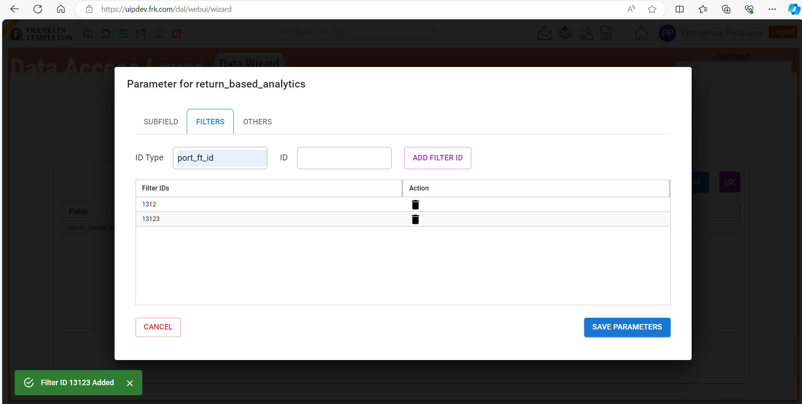

### Nested Others

* Key,value is the input type, user can enter in key, value text boxs and click the add key value button to use to add in the grid. User can add multiple key and value in th table.
* Use “Delete icon” remove the key and value in the table.

DAL Excel Data Wizard screens 6.3

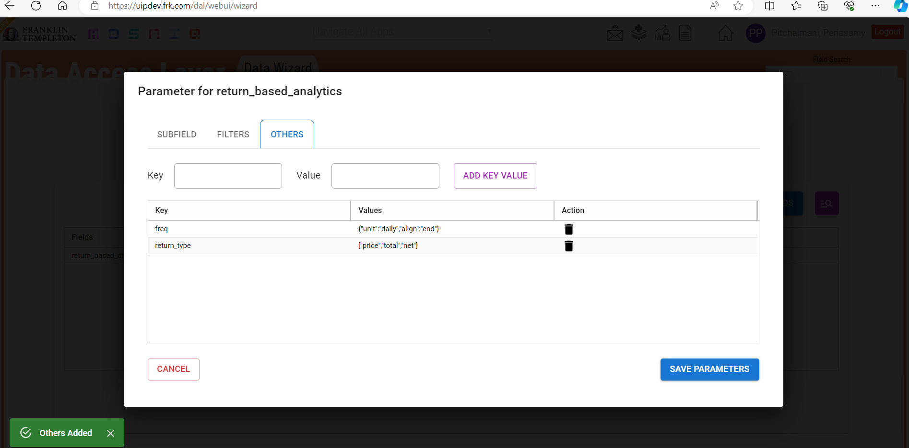

### Save Parameters

* Use Save Parameter button to save all parameters in page.
* Use “Cancel” button to close the “Field Input” screen.

DAL Excel Data Wizard screens 7.1

## Entity Search

* Entity search screen is used to call from API based on search string in the search input.
* This screen also has an option for Tab Page for Entity, search the entity, Key Value pair and select from excel. To search the entity, enter minimum three letters in the search box and click search button.
* Search button will popup search screen.
* This screen has another option also available to add entity by Key and Value Pair.
* The ID Type is auto filled property.
* The ID Date is to input date.
* “Select From Excel” will help user to add the entities from excel to selection table.
* Use “Previous” button to go to field selection page.
* Use “Next” button to go to Date selection page.
* Use “Delete icon” remove the Entity value in the table.
* Use the Cancel button to close the entity Input Screen.

Entity selection for key and value entity

* Multiple Entities can select using in the table.
* Select entity button will add the selected record(s) to entity selection screen.
* DAL Excel Data Wizard screens 7.2

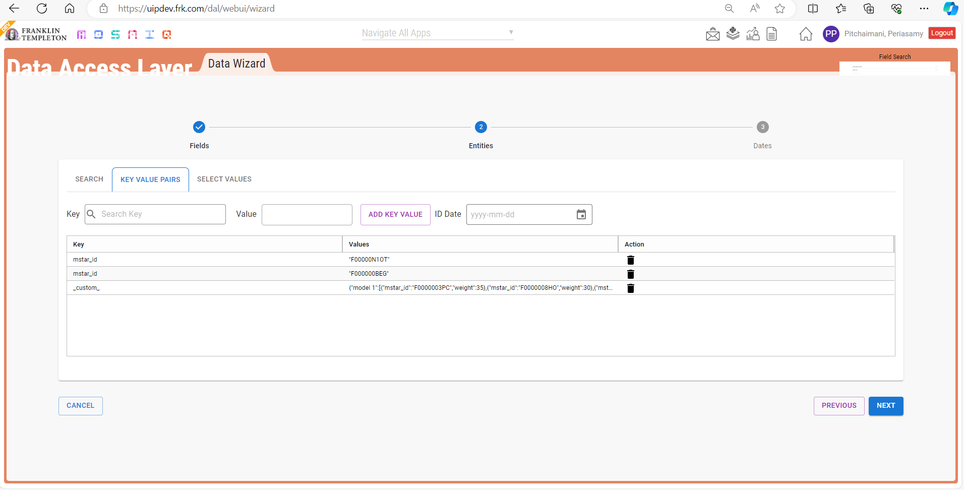

DAL Excel Data Wizard screens 7.3

Entity selection for select from excel entity.

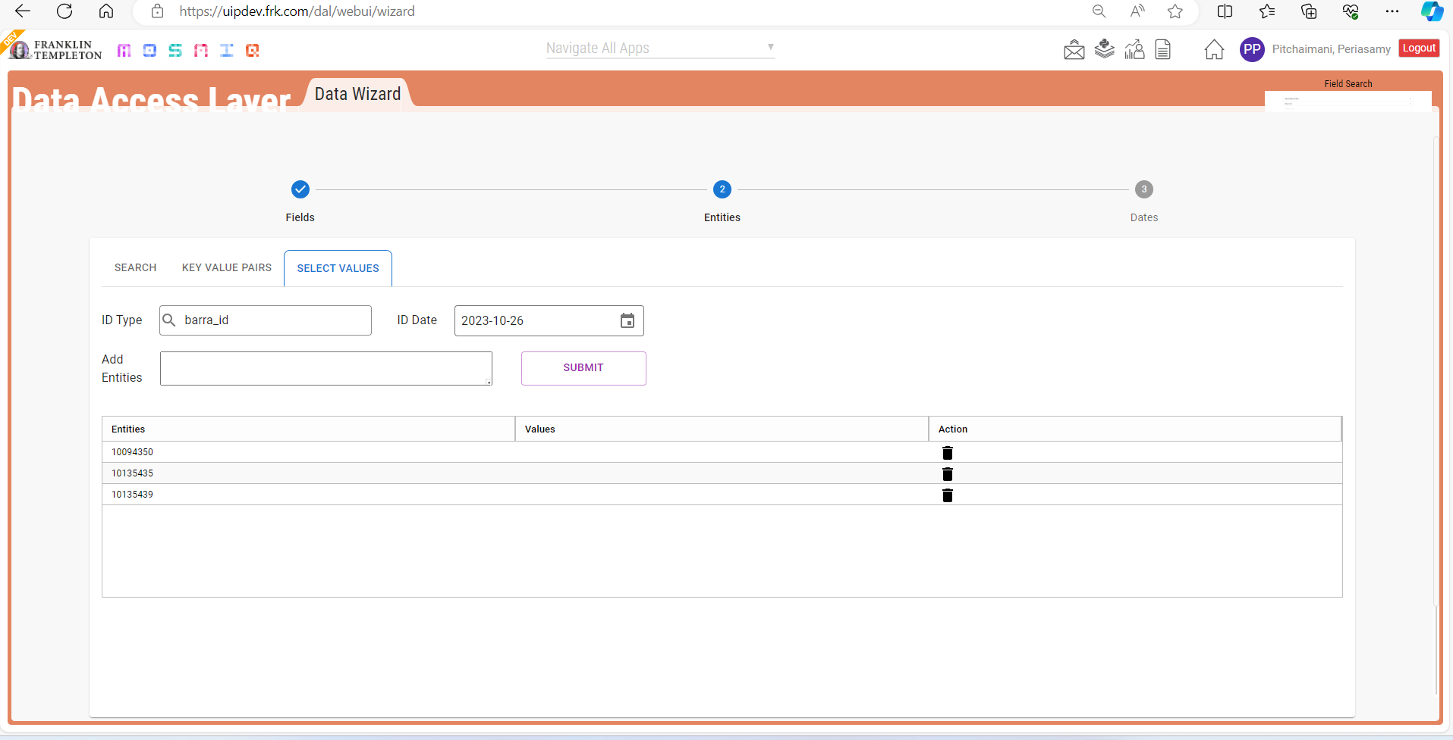

## Date Selection

* Date Selection screen is used to input date type and other options for Date.
* Three type of date is available i.e., Series, Snapshot and Rang.
  + Range is used to add date as starting and end dates.
  + Snapshot is used to add multiple dates.
  + Series is same as Snapshot except some minor difference.
* Other date options i.e., Frequency, Fill Missing, Align, Interval and Lookback is available only to Range Date type.
* Future dates are not available.
* “Select Date from Excel” will help user to add the dates from excel to selection table.
* Use “Previous” button to go to Entity selection page.
* Use “Delete icon” remove the date value in the table.
* Use “Fetch Data” button to get the data from API and populate it in excel.

DAL Excel Data Wizard screens 8

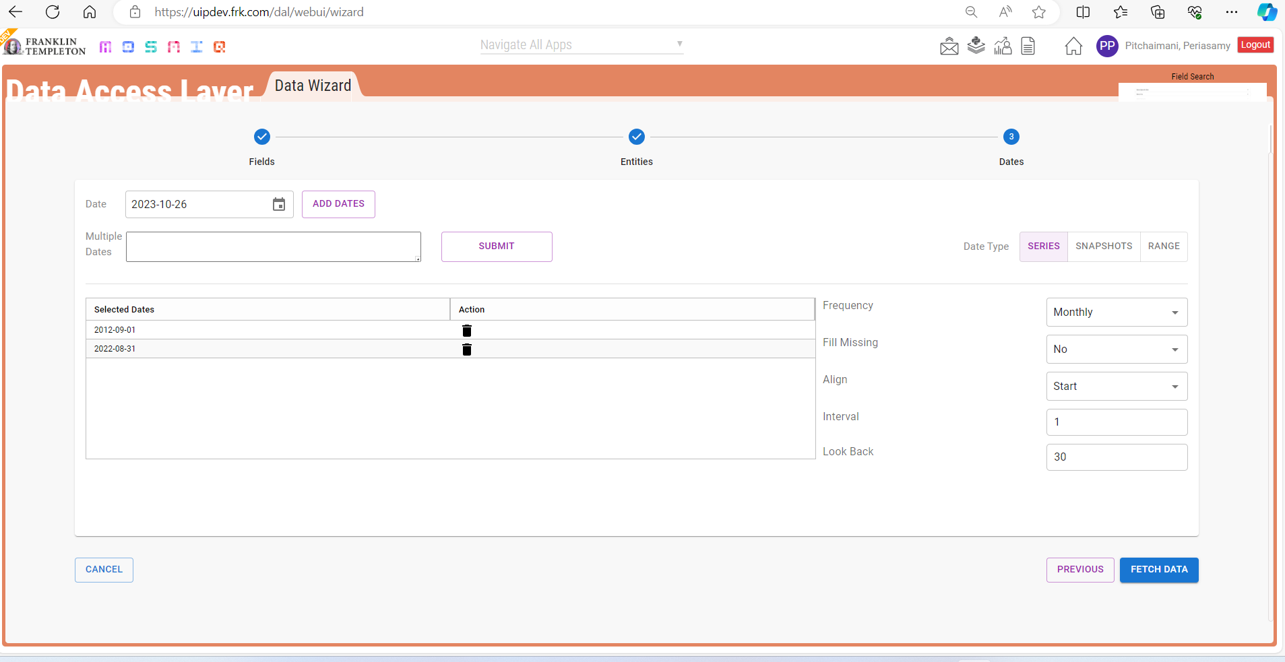

## Report Screen

* The Report is generated in excel and it will be saved in the default downloads folder.
* User can click the file and get data from the downloads folder.

DAL Excel Data Wizard screens 9

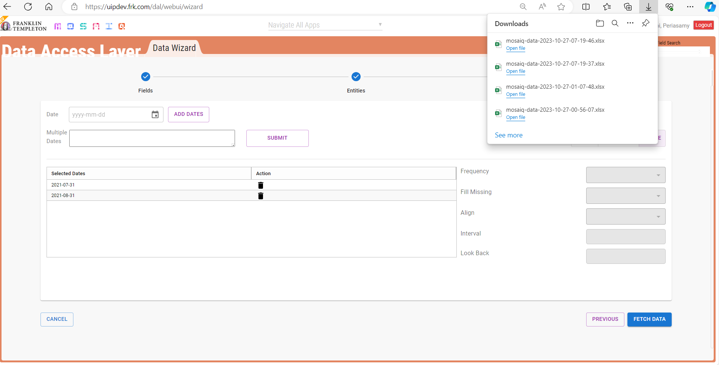

* Below is the output for above request.
* User can verify the response from the API for given request.

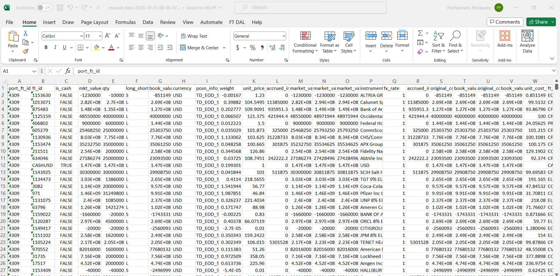

# Excel Plugin Approach

## Ribbon:

Will have the options available in DAL-Plugin.

* About
* Settings
* Fetch Data

DAL Excel Plugin screens 10

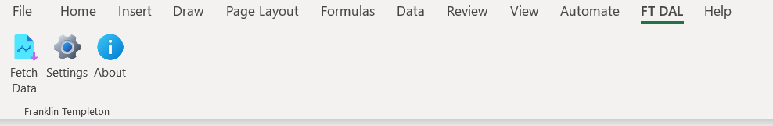

## Settings Screen:

* Setting screen is used to input the Username (Email ID), and password to validate the user access.

Also, this option is used to select the environment such as -

* Production: This option will send the request to the Production Environment API’s. This is the default option.
* Development: This option will send the request to the Development Environment API’s.
* Test: This option will send the request to the Test Environment API’s.
* UAT: This option will send the request to the UAT Environment API’s.

DAL Excel Plugin screens 11

## Fetch Data Screen:

* User can click the “FT-DAL” button from the excel plugin fetch data link will find the Rippon.
* User can click the “Fetch Data” link and the Data wizard web page open from the excel plugin.

DAL Excel Plugin screens 12

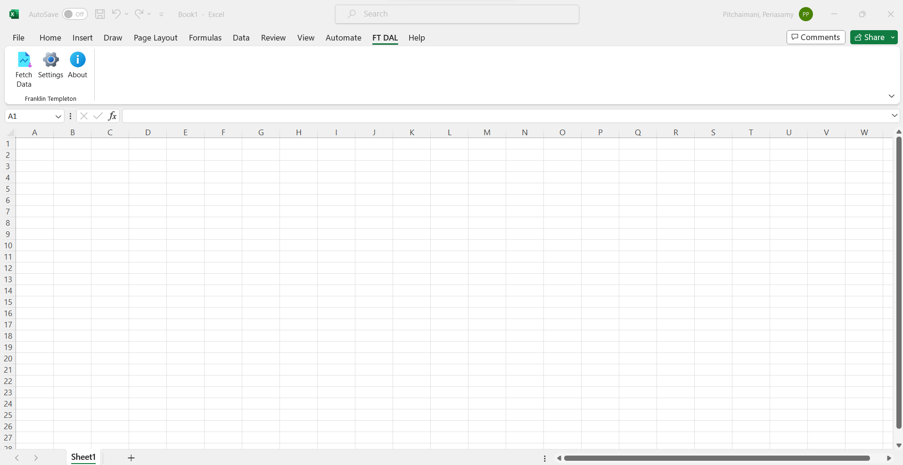

## Loading Data Wizard Screen:

* Once click the fetch data button from excel plugin the below loading screed will be open.
* User can use to login with SSO to connect the Mosaiq Portal from Excel plugin as well.

DAL Excel Plugin screens 13

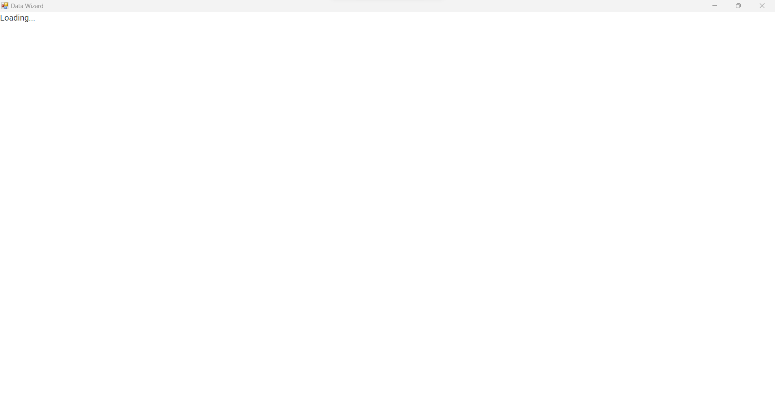

## Loading Data Wizard Screen:

* Once loading is completed then the user can use his credentials to login with the help of SSO to connect Mosiq Portal.

DAL Excel Plugin screens 14

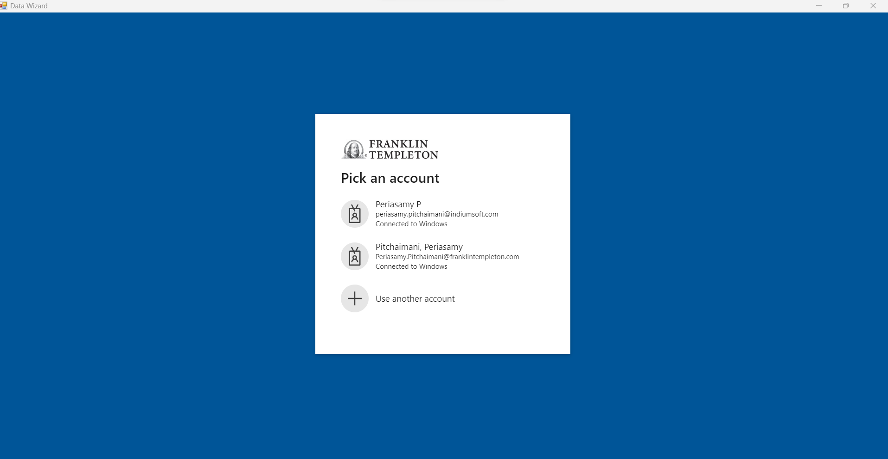

## Data Wizard Screen with Mosaiq:

* After successful login with SSO, directly open the landing JSON input screen will open through excel plugin.
* After that, the user can start to create a new request same as Mosaiq approach from earlier one.
* User can click the “Fetch Data” button will send the JSON to API and populate results from the API in the New Excel sheet with help of DAL API response.
* Use “Clear Input” button to clear existing JSON Input.
* Use “Wizard” button to generate JSON request by entering input for Fields, Entities and Dates.
* Use “Cancel Button” to close the JSON Input Screen.

DAL Excel Plugin screens 15

Below is Select multiple Entity from Excel.

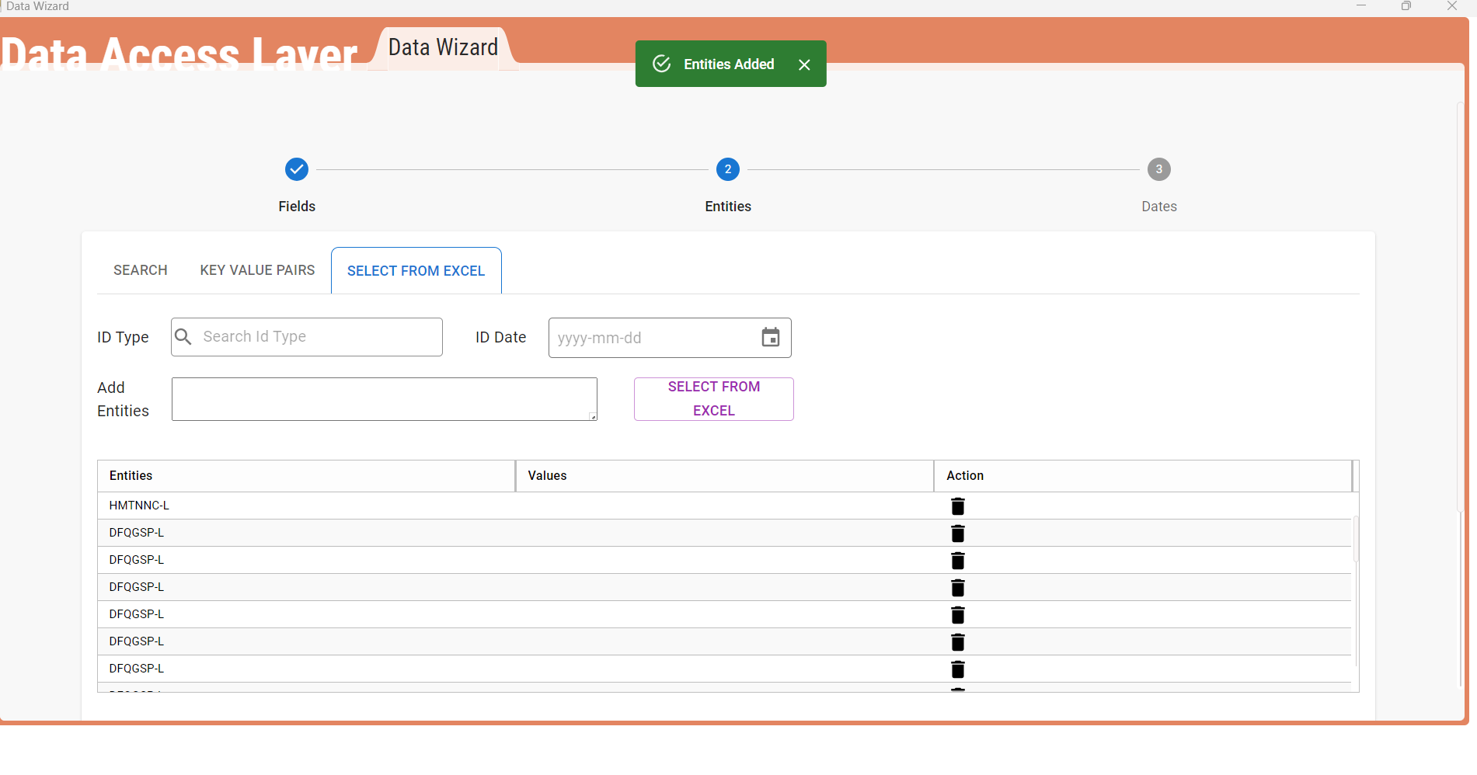

Below is Select multiple Date from Excel.

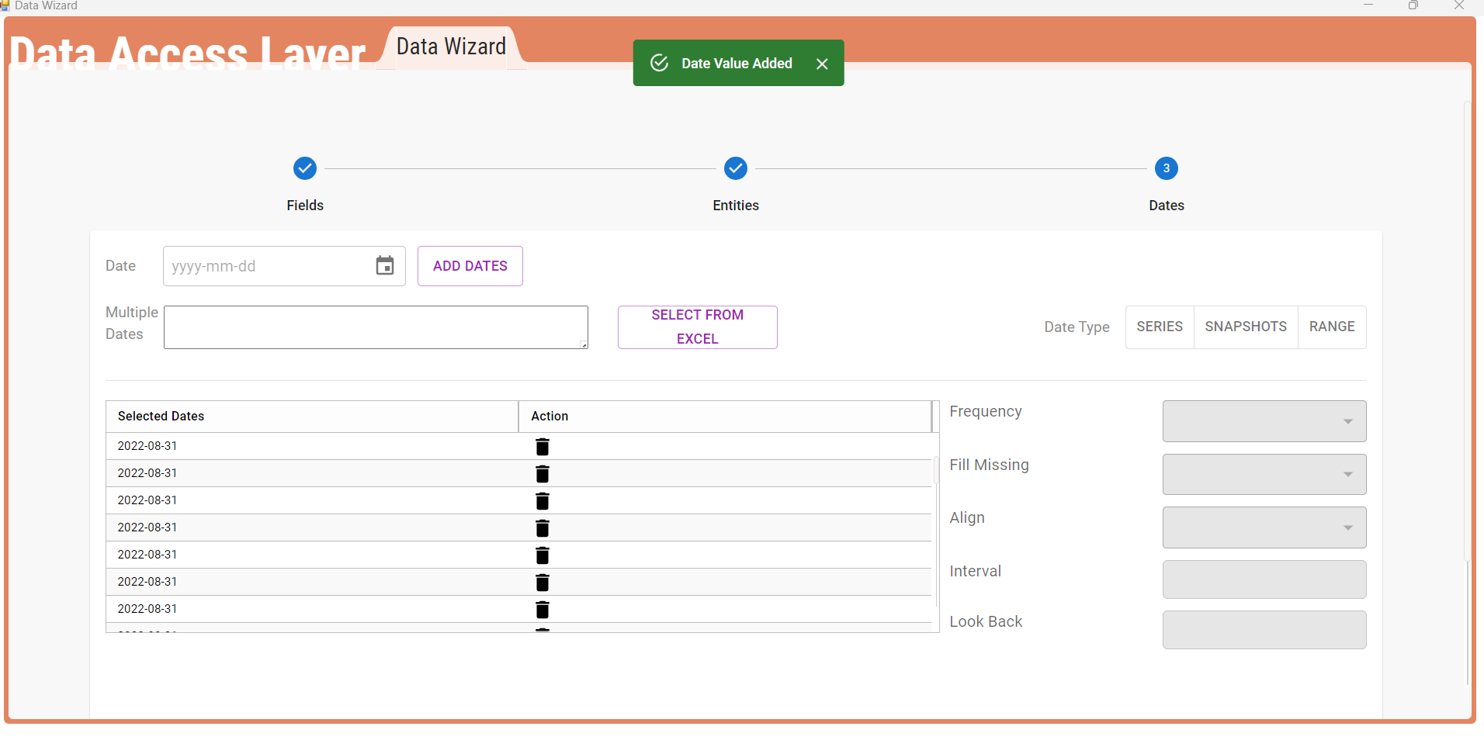

## Report from excel Plugin:

* The data will be displayed in after clicking “Fetch Data” button from the date and Json screen.
* User can verify the response from the API for given request.

DAL Excel Plugin screens 16

